Lab 1 — CSV Data Analysis + Missing Data + Aggregation Reports

Learning Goals
By the end of this lab, you will be able to:
- Install external Python packages using pip
- Load and analyze CSV files using Pandas
- Handle missing data safely
- Perform grouping and aggregation
- Generate simple summary reports
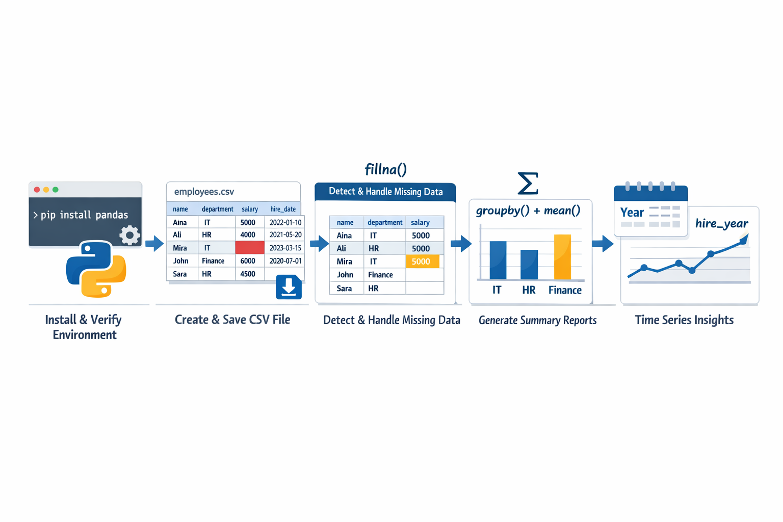

Part 0 — Environment Setup (Very Important)

Step 0.1 — Check Python Installation
In your terminal:
python --version
If not found, try:
python3 --version
You must have Python 3.8+

Step 0.2 — Check pip
python -m pip --version

If pip is missing:
python -m ensurepip --upgrade

Step 0.3 — Install Required Packages
Install Pandas (NumPy will be installed automatically):
python -m pip install pandas
Optional (explicit install):
python -m pip install pandas numpy

Step 0.4 — Verify Installation
Open Python:
python
Then test:
import pandas as pd
print(pd.__version__)
If no error appears → setup complete ✅
Exit Python:
exit()

Setup
Create a new file:
lab_csv_analysis.py

Run:
python lab_csv_analysis.py

Part 1 — Create a Sample CSV File

Step 1 — Create a sample dataset
Add this at the top of your file:
import pandas as pd

print("=== Lab: CSV Data Analysis with Pandas ===")

data = {
"name": ["Aina", "Ali", "Mira", "John", "Sara"],
"department": ["IT", "HR", "IT", "Finance", "HR"],
"salary": [5000, 4000, None, 6000, 4500],
"hire_date": [
"2022-01-10",
"2021-05-20",
"2023-03-15",
"2020-07-01",
None
]
}

df = pd.DataFrame(data)

df.to_csv("employees.csv", index=False)

Run the file once to generate:
employees.csv

Part 2 — Load and Explore CSV Data

Step 2 — Load CSV
Add below:

print("\n--- Part 1: Load CSV ---")

df = pd.read_csv("employees.csv")

print(df)
print("\nData Types:")
print(df.dtypes)
Run and observe the structure.

Part 3 — Handle Missing Data

Step 3 — Detect Missing Values

print("\n--- Missing Data ---")
print(df.isnull().sum())

Step 4 — Fix Missing Salary
Option 1: Replace missing salary with average

avg_salary = df["salary"].mean()
df["salary"] = df["salary"].fillna(avg_salary)

print("\nAfter filling salary:")
print(df)

Step 5 — Convert hire_date to datetime

df["hire_date"] = pd.to_datetime(df["hire_date"], errors="coerce")

Part 4 — Grouping & Aggregation

Step 6 — Average Salary by Department

print("\n--- Average Salary by Department ---")

grouped = df.groupby("department")["salary"].mean()
print(grouped)

Step 7 — Count Employees by Department
print("\n--- Employee Count by Department ---")

count = df.groupby("department")["name"].count()
print(count)

Part 5 — Time Series Example

Step 8 — Extract Year from hire_date
df["hire_year"] = df["hire_date"].dt.year

print("\n--- Employees by Hire Year ---")
print(df.groupby("hire_year")["name"].count())

Final Expected Output
You should see:
- CSV loaded correctly
- Missing salary detected
- Salary replaced with average
- Grouped salary results
- Department counts
- Time-based grouping

Reflection Questions
- Why does Pandas convert numeric columns automatically?
- What happens if missing values are not handled?
- Why is grouping powerful for reporting?
- When would you drop missing data instead of filling it?

Optional Extensions (If Time Allows)

Export Aggregation Report to JSON

grouped.to_json("salary_report.json")

Sort Employees by Salary

print(df.sort_values(by="salary", ascending=False))

Add Error Handling for Missing CSV

try:
df = pd.read_csv("employees.csv")
except FileNotFoundError:
print("CSV file not found.")

Submission Checklist
Your file must:
- Install pandas successfully
- Load CSV using pandas
- Handle missing data
- Perform grouping & aggregation
- Generate clean output without errors

Key Takeaways
- pip allows installing external libraries
- Pandas simplifies CSV processing dramatically
- Missing data must be handled intentionally
- Grouping enables business reporting
- Pandas combines NumPy power with table structure

Lab 2 — Web Scraping + Excel/CSV Automation

Learning Goals
By the end of this lab, you will be able to:
- Scrape structured data from a website
- Parse HTML using BeautifulSoup
- Store scraped data into CSV
- Load and process CSV using pandas
- Generate automated Excel reports
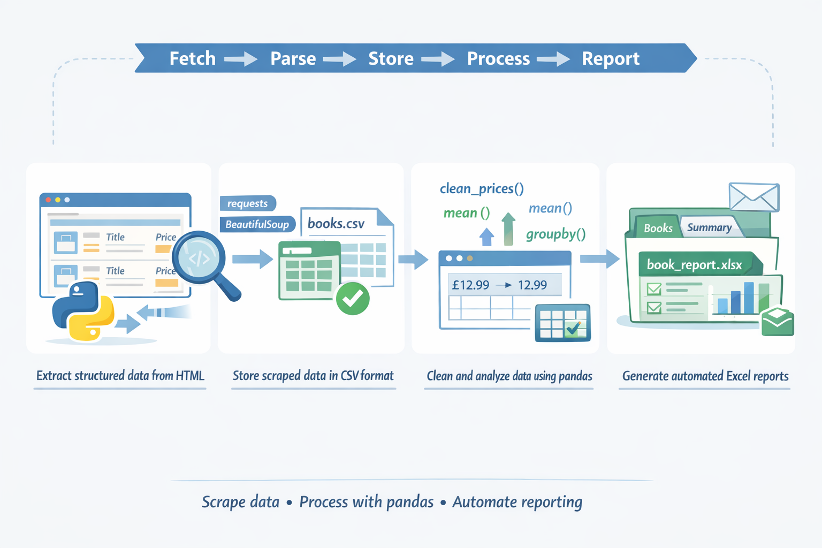

Setup

Deliverable File

lab_scrape_and_excel_automation.py

Step 0 — Install Required Packages
Run in terminal:
pip install requests beautifulsoup4 pandas openpyxl

Confirm installation:
pip list

Part 1 — Scraping Website Data

Step 1 — Import Required Modules
Create your file and add:
print("=== Lab: Web Scraping + Excel Automation ===")

import requests
from bs4 import BeautifulSoup
import pandas as pd
Run the file to confirm no errors.

Step 2 — Choose a Safe Test Website
We will use:
https://books.toscrape.com/

(This site is designed for scraping practice.)

Step 3 — Fetch the Webpage
Add:
def fetch_page(url):
response = requests.get(url)
response.raise_for_status()
return response.text
Test it:
html = fetch_page("https://books.toscrape.com/")
print("Page downloaded successfully")

Step 4 — Parse HTML with BeautifulSoup
Add:
def parse_books(html):
soup = BeautifulSoup(html, "html.parser")
books = []

for item in soup.select(".product_pod"):
title = item.h3.a["title"]
price = item.select_one(".price_color").text
books.append({
"title": title,
"price": price
})

return books

Step 5 — Test Scraping
Add:
print("\n--- Scraping Books ---")
book_data = parse_books(html)

print("Books found:", len(book_data))
print("Sample:", book_data[:3])

You should see book titles and prices.

Part 2 — Save Scraped Data to CSV

Step 6 — Save to CSV
Add:
def save_to_csv(data, filename):
df = pd.DataFrame(data)
df.to_csv(filename, index=False)
Test it:
save_to_csv(book_data, "books.csv")
print("Saved to books.csv")
Confirm that books.csv exists in your folder.

Part 3 — Automate Excel Processing

Step 7 — Load CSV into Pandas
Add:
def load_csv(filename):
return pd.read_csv(filename)

Test:
df = load_csv("books.csv")
print("\nLoaded DataFrame:")
print(df.head())

Step 8 — Clean Price Column
Prices look like:
Â£53.74
Add:
def clean_prices(df):
df["price"] = (
df["price"]
.str.replace("Â£", "", regex=False)
.astype(float)
)
return df

Test:
df = clean_prices(df)
print("\nCleaned Prices:")
print(df.head())

Part 4 — Data Analysis & Excel Report

Step 9 — Generate Summary Report
Add:
def generate_summary(df):
summary = {
"Total Books": len(df),
"Average Price": df["price"].mean(),
"Max Price": df["price"].max(),
"Min Price": df["price"].min()
}
return pd.DataFrame([summary])

Test:
summary_df = generate_summary(df)
print("\nSummary:")
print(summary_df)

Step 10 — Save Excel Report
Add:
def save_to_excel(data_df, summary_df, filename):
with pd.ExcelWriter(filename) as writer:
data_df.to_excel(writer, sheet_name="Books", index=False)
summary_df.to_excel(writer, sheet_name="Summary", index=False)

Test:
save_to_excel(df, summary_df, "book_report.xlsx")
print("Excel report generated: book_report.xlsx")

Final Main Flow
At the bottom of your file:

def main():
url = "https://books.toscrape.com/"

html = fetch_page(url)
books = parse_books(html)

save_to_csv(books, "books.csv")

df = load_csv("books.csv")
df = clean_prices(df)

summary = generate_summary(df)
save_to_excel(df, summary, "book_report.xlsx")

print("\nAutomation Complete ✅")

if __name__ == "__main__":
main()

Expected Output
You should see:
- Website scraped successfully
- books.csv created
- Cleaned price column
- Excel file book_report.xlsx generated
- Summary sheet with average/min/max

Important Notes
- Only scrape websites that allow scraping
- Respect robots.txt
- Add delays for large-scale scraping
- Never scrape private or restricted content

Optional Extensions (Advanced)

1) Scrape multiple pages (pagination)
If the site uses page URLs like ...?page=1, loop through pages:
import requests
from bs4 import BeautifulSoup

def scrape_pages(base_url, start=1, end=5):
all_rows = []

for page in range(start, end + 1):
url = f"{base_url}?page={page}"
r = requests.get(url, timeout=15)
r.raise_for_status()

soup = BeautifulSoup(r.text, "html.parser")

# EXAMPLE selectors (change to match your target site)
for card in soup.select(".book"):
title = card.select_one(".title").get_text(strip=True)
price_text = card.select_one(".price").get_text(strip=True)
price = float(price_text.replace("RM", "").strip())
all_rows.append({"page": page, "title": title, "price": price})

return all_rows
✅ If the website has a “Next” button, stop when next link is missing.

2) Add timestamp to Excel filename
from datetime import datetime

timestamp = datetime.now().strftime("%Y%m%d_%H%M%S")
filename = f"books_report_{timestamp}.xlsx"
print(filename)
Example output: books_report_20260211_073512.xlsx

3) Add error handling for failed requests
Use try/except + timeouts + status checks:
import requests

def safe_get(url):
try:
r = requests.get(url, timeout=15)
r.raise_for_status()
return r.text
except requests.Timeout:
print(f"[ERROR] Timeout: {url}")
except requests.HTTPError as e:
print(f"[ERROR] HTTP error: {url} -> {e}")
except requests.RequestException as e:
print(f"[ERROR] Request failed: {url} -> {e}")
return None
Then:
html = safe_get(url)
if html is None:
# skip page or retry
pass

4) Filter books above certain price

def filter_by_price(rows, min_price=50.0):
return [r for r in rows if r["price"] > min_price]
Example:
expensive = filter_by_price(all_rows, min_price=80.0)
print("Expensive books:", len(expensive))

5) Send automated email with report attachment
Use SMTP (Gmail requires App Password / proper setup). This sends an email with an Excel attachment:
import smtplib
from email.message import EmailMessage
from pathlib import Path

def send_email_with_attachment(
smtp_host,
smtp_port,
sender_email,
sender_password,
to_email,
subject,
body,
attachment_path
):
msg = EmailMessage()
msg["From"] = sender_email
msg["To"] = to_email
msg["Subject"] = subject
msg.set_content(body)

file_path = Path(attachment_path)
data = file_path.read_bytes()
msg.add_attachment(
data,
maintype="application",
subtype="octet-stream",
filename=file_path.name
)

with smtplib.SMTP_SSL(smtp_host, smtp_port) as server:
server.login(sender_email, sender_password)
server.send_message(msg)

print("✅ Email sent.")
Example call:
send_email_with_attachment(
smtp_host="smtp.gmail.com",
smtp_port=465,
sender_email="your_email@gmail.com",
sender_password="YOUR_APP_PASSWORD",
to_email="receiver@gmail.com",
subject="Books Report",
body="Attached is the latest scraped books report.",
attachment_path="books_report_20260211_073512.xlsx"
)
✅ Best practice: store credentials in .env (never hardcode).

Key Takeaways
- Scraping = extract structured HTML data
- CSV = portable data format
- pandas = powerful data processing tool
- Excel automation replaces manual reporting
- Automation pipeline = Fetch → Parse → Store → Process → Report

Lab 3 — Train a Classifier → Evaluate Accuracy → Save & Reload Model

Learning Goals
By the end of this lab, you will be able to:
- Train a classification model using Scikit-Learn
- Evaluate model performance using accuracy
- Save a trained model using joblib
- Reload the model and make predictions again
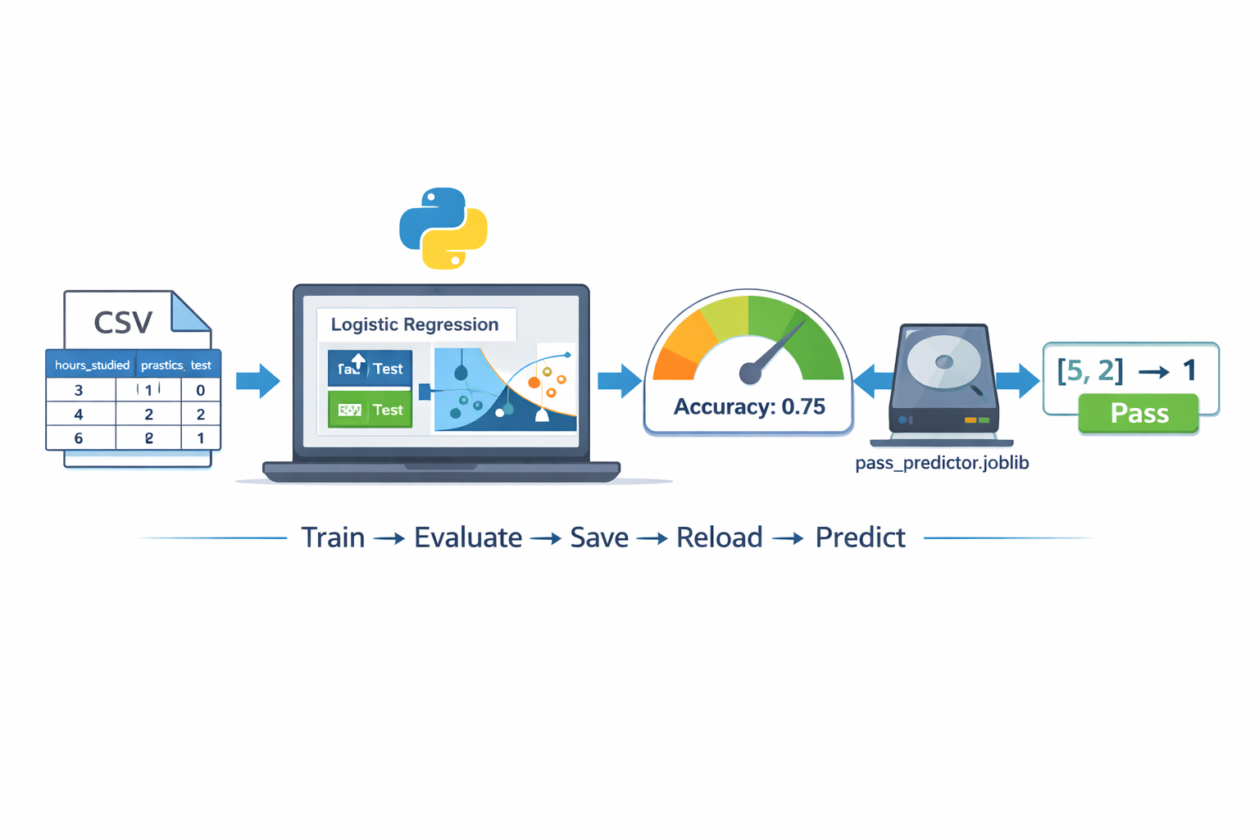

Setup

Deliverable file
Create one file:
lab_classifier_joblib.py

Step 0 — Install packages (one-time)
Run in terminal:
python -m pip install scikit-learn pandas joblib
✅ Check installed:
python -c "import sklearn, pandas, joblib; print('OK')"

Part 1 — Prepare a Dataset (CSV)

Step 1 — Create a CSV file
Create a file named:
students.csv

Copy–paste this data:

hours_studied,practice_tests,passed
1,0,0
2,0,0
2,1,0
3,1,0
4,1,1
4,2,1
5,2,1
6,2,1
6,3,1
7,3,1
3,0,0
5,1,1

- passed is the target label: 0 = fail, 1 = pass

Part 2 — Load Data + Split Train/Test

Step 2 — Start your Python file
Open lab_classifier_joblib.py and paste:
print("=== Lab: Classifier + Accuracy + Joblib ===")

Step 3 — Import libraries
Add:

import pandas as pd
from sklearn.model_selection import train_test_split
from sklearn.linear_model import LogisticRegression
from sklearn.metrics import accuracy_score
import joblib

Step 4 — Load CSV + create X and y
Add:
df = pd.read_csv("students.csv")
print("\nDataset preview:")
print(df.head())

X = df[["hours_studied", "practice_tests"]]
y = df["passed"]

Step 5 — Split into training and testing sets
Add:
X_train, X_test, y_train, y_test = train_test_split(
X, y, test_size=0.3, random_state=42
)

print("\nTrain size:", len(X_train))
print("Test size:", len(X_test))

Part 3 — Train a Classifier

Step 6 — Train Logistic Regression model
Add:
model = LogisticRegression()
model.fit(X_train, y_train)

print("\nModel trained ✅")

Part 4 — Evaluate Accuracy

Step 7 — Predict and compute accuracy
Add:

y_pred = model.predict(X_test)

acc = accuracy_score(y_test, y_pred)
print("\nPredictions:", list(y_pred))
print("Actual:", list(y_test))
print("Accuracy:", round(acc, 3))

✅ You should see an accuracy value like:
Accuracy: 0.75
(Exact result may vary slightly)

Part 5 — Save & Reload Model with Joblib

Step 8 — Save the trained model
Add:
joblib.dump(model, "pass_predictor.joblib")
print("\nModel saved to pass_predictor.joblib ✅")

Step 9 — Reload the model and test again
Add:
loaded_model = joblib.load("pass_predictor.joblib")
print("Model reloaded ✅")

sample = [[5, 2]] # hours_studied=5, practice_tests=2
pred = loaded_model.predict(sample)[0]

print("\nSample input:", sample[0])
print("Predicted class (0=fail, 1=pass):", pred)

Final Step — Full Program Structure
Wrap everything in main() (ready to paste full file):

import pandas as pd
from sklearn.model_selection import train_test_split
from sklearn.linear_model import LogisticRegression
from sklearn.metrics import accuracy_score
import joblib

def main():
print("=== Lab: Classifier + Accuracy + Joblib ===")

# Part 1: Load data
df = pd.read_csv("students.csv")
print("\nDataset preview:")
print(df.head())

X = df[["hours_studied", "practice_tests"]]
y = df["passed"]

# Part 2: Train/test split
X_train, X_test, y_train, y_test = train_test_split(
X, y, test_size=0.3, random_state=42
)

print("\nTrain size:", len(X_train))
print("Test size:", len(X_test))

# Part 3: Train model
model = LogisticRegression()
model.fit(X_train, y_train)
print("\nModel trained ✅")

# Part 4: Evaluate accuracy
y_pred = model.predict(X_test)
acc = accuracy_score(y_test, y_pred)

print("\nPredictions:", list(y_pred))
print("Actual:", list(y_test))
print("Accuracy:", round(acc, 3))

# Part 5: Save model
joblib.dump(model, "pass_predictor.joblib")
print("\nModel saved to pass_predictor.joblib ✅")

# Part 6: Reload model
loaded_model = joblib.load("pass_predictor.joblib")
print("Model reloaded ✅")

sample = [[5, 2]]
pred = loaded_model.predict(sample)[0]
print("\nSample input:", sample[0])
print("Predicted class (0=fail, 1=pass):", pred)

if __name__ == "__main__":
main()

Submission Checklist
Your submission must include:
- students.csv
- lab_classifier_joblib.py
- Output showing:
  - Model trained
  - Accuracy printed
  - Model saved and reloaded
  - A sample prediction

Optional Extensions
- Print confusion matrix

from sklearn.metrics import confusion_matrix, ConfusionMatrixDisplay
import matplotlib.pyplot as plt

# after you predict
y_pred = model.predict(X_test)

cm = confusion_matrix(y_test, y_pred)
print("Confusion Matrix:\n", cm)

# optional: nicer display (opens a small plot window)
ConfusionMatrixDisplay(confusion_matrix=cm).plot()
plt.show()

- Try a different classifier (DecisionTreeClassifier)
from sklearn.tree import DecisionTreeClassifier

tree_model = DecisionTreeClassifier(
random_state=42,
max_depth=3 # you can change this
)

tree_model.fit(X_train, y_train)
tree_pred = tree_model.predict(X_test)

from sklearn.metrics import accuracy_score
print("DecisionTree accuracy:", accuracy_score(y_test, tree_pred))

If you’re saving with joblib:
import joblib
joblib.dump(tree_model, "model_tree.joblib")

- Add more features to CSV (sleep_hours, attendance)

study_hours,sleep_hours,attendance,label
2.0,7.5,90,pass
1.0,6.0,60,fail
...

Update your feature selection
import pandas as pd

df = pd.read_csv("students.csv")

feature_cols = ["study_hours", "sleep_hours", "attendance"]
X = df[feature_cols]
y = df["label"]

- Save feature names together with the model in a dictionary file
import joblib

artifact = {
"model": model,
"feature_names": list(X.columns),
"label_name": "label"
}

joblib.dump(artifact, "model_with_features.joblib")
print("Saved model + feature names!")

Load and use later
artifact = joblib.load("model_with_features.joblib")
loaded_model = artifact["model"]
feature_names = artifact["feature_names"]

# Example: predict from a new row (must match feature order)
import pandas as pd
new_data = pd.DataFrame([[2.5, 7.0, 85]], columns=feature_names)
print("Prediction:", loaded_model.predict(new_data))

Key Takeaways
- Web scraping extracts structured data from HTML
Using requests and BeautifulSoup, we can convert webpage content into clean, structured Python data (lists & dictionaries).
- Automation replaces repetitive manual reporting
The full pipeline (Fetch → Parse → Store → Process → Report) eliminates manual copy-paste into Excel.
- pandas simplifies data cleaning and analysis
DataFrame operations make it easy to clean columns, compute averages, and generate summary reports in just a few lines.
- CSV is portable; Excel is presentation-ready
CSV is ideal for raw storage and portability, while Excel provides professional multi-sheet reporting with summaries and charts.
- Production automation requires robustness
Error handling, pagination, filtering, timestamps, and email automation transform a simple script into a scalable automation workflow.

Lab 4 — Build a Real-Time Face Detection App (OpenCV + Haar Cascade)

Learning Goals
By the end of this lab, you will be able to:
- Open a webcam stream using OpenCV
- Detect faces in real-time using a pre-trained Haar Cascade
- Draw bounding boxes + show face count
- Add simple keyboard controls (quit, screenshot)
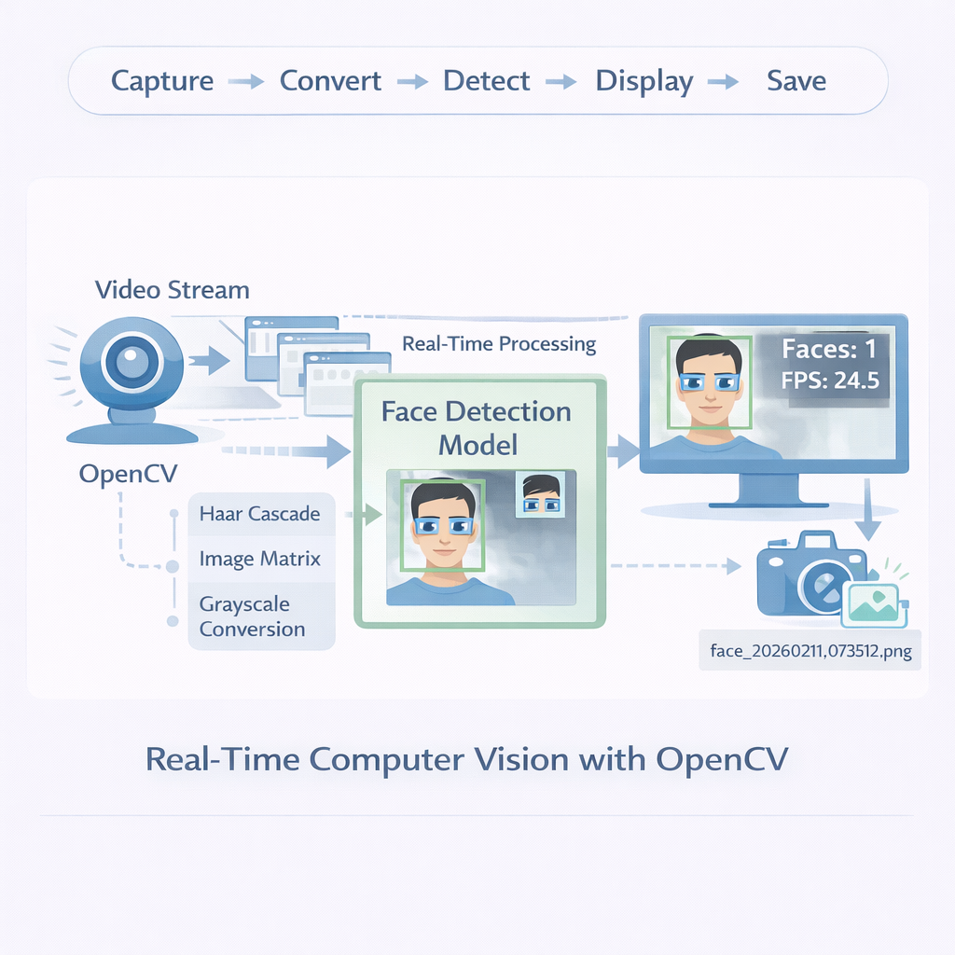

Setup

Deliverable file
Create one file:
lab_realtime_face_detection.py

Step 0 — Install OpenCV
Run in terminal:
python -m pip install opencv-python
Quick test:
python -c "import cv2; print(cv2.__version__)"

Part 1 — Webcam + Window (No Detection Yet)

Step 1 — Start the file + open webcam

import cv2

print("=== Lab: Real-Time Face Detection ===")

cap = cv2.VideoCapture(0) # 0 = default webcam

if not cap.isOpened():
raise RuntimeError("❌ Cannot open webcam. Try changing 0 to 1.")

while True:
ret, frame = cap.read()
if not ret:
print("❌ Failed to read frame")
break

cv2.imshow("Webcam Preview (press q to quit)", frame)

if cv2.waitKey(1) & 0xFF == ord("q"):
break

cap.release()
cv2.destroyAllWindows()

Run:
python lab_realtime_face_detection.py

Expected: live webcam window. Press q to quit.

Part 2 — Load Haar Cascade Model

Step 2 — Add the face detector
Replace your file content with this updated version (copy–paste):
import cv2

print("=== Lab: Real-Time Face Detection ===")

# Load pre-trained Haar Cascade model (comes with OpenCV)
face_cascade = cv2.CascadeClassifier(
cv2.data.haarcascades + "haarcascade_frontalface_default.xml"
)

if face_cascade.empty():
raise RuntimeError("❌ Haar cascade not loaded. Check OpenCV installation.")

cap = cv2.VideoCapture(0)
if not cap.isOpened():
raise RuntimeError("❌ Cannot open webcam. Try changing 0 to 1.")

while True:
ret, frame = cap.read()
if not ret:
print("❌ Failed to read frame")
break

cv2.imshow("Webcam Preview (press q to quit)", frame)

if cv2.waitKey(1) & 0xFF == ord("q"):
break

cap.release()
cv2.destroyAllWindows()
Run again to confirm no errors.

Part 3 — Detect Faces + Draw Boxes

Step 3 — Convert to grayscale + detect faces
Update the loop section to:

gray = cv2.cvtColor(frame, cv2.COLOR_BGR2GRAY)

faces = face_cascade.detectMultiScale(
gray,
scaleFactor=1.2,
minNeighbors=5,
minSize=(60, 60)
)

for (x, y, w, h) in faces:
cv2.rectangle(frame, (x, y), (x + w, y + h), (0, 255, 0), 2)

Full file (ready-to-paste) is below in Part 6 if you prefer.
Run:
- You should see green rectangles around faces.

Part 4 — Add Face Count Text

Step 4 — Overlay face count on screen
Add after detection:

cv2.putText(
frame,
f"Faces: {len(faces)}",
(20, 40),
cv2.FONT_HERSHEY_SIMPLEX,
1,
(255, 255, 255),
2
)

Run and verify text shows “Faces: X”.

Part 5 — Add Screenshot Feature

Step 5 — Press s to save a screenshot
Inside the loop, replace the key logic with:

key = cv2.waitKey(1) & 0xFF

if key == ord("q"):
break

if key == ord("s"):
cv2.imwrite("snapshot.jpg", frame)
print("✅ Saved snapshot.jpg")

Try pressing s while running.

Part 6 — FINAL FULL CODE (Ready to Paste)
Copy–paste everything below into lab_realtime_face_detection.py:
import cv2

print("=== Lab: Real-Time Face Detection ===")

# Load pre-trained Haar Cascade model (bundled with OpenCV)
face_cascade = cv2.CascadeClassifier(
cv2.data.haarcascades + "haarcascade_frontalface_default.xml"
)

if face_cascade.empty():
raise RuntimeError("❌ Haar cascade not loaded. Check OpenCV installation.")

cap = cv2.VideoCapture(0) # change to 1 if webcam not found
if not cap.isOpened():
raise RuntimeError("❌ Cannot open webcam. Try changing 0 to 1.")

print("Controls: press 's' to save screenshot, 'q' to quit.")

while True:
ret, frame = cap.read()
if not ret:
print("❌ Failed to read frame")
break

# Convert to grayscale (face detection works better)
gray = cv2.cvtColor(frame, cv2.COLOR_BGR2GRAY)

# Detect faces
faces = face_cascade.detectMultiScale(
gray,
scaleFactor=1.2,
minNeighbors=5,
minSize=(60, 60)
)

# Draw bounding boxes
for (x, y, w, h) in faces:
cv2.rectangle(frame, (x, y), (x + w, y + h), (0, 255, 0), 2)

# Show face count
cv2.putText(
frame,
f"Faces: {len(faces)}",
(20, 40),
cv2.FONT_HERSHEY_SIMPLEX,
1,
(255, 255, 255),
2
)

# Display window
cv2.imshow("Real-Time Face Detection", frame)

# Keyboard control
key = cv2.waitKey(1) & 0xFF
if key == ord("q"):
break
if key == ord("s"):
cv2.imwrite("snapshot.jpg", frame)
print("✅ Saved snapshot.jpg")

cap.release()
cv2.destroyAllWindows()
print("Done ✅")

Expected Output
You should see:
- Webcam window with face boxes
- Face count text updating live
- Press s → saves snapshot.jpg
- Press q → quits safely

Optional Extensions (If Time Allows)
- Detect eyes too (Haar cascade for eyes)
Add these near your face cascade setup:

eye_cascade = cv2.CascadeClassifier(
cv2.data.haarcascades + "haarcascade_eye.xml"
)
Inside your loop, after you detect faces:
for (x, y, w, h) in faces:
cv2.rectangle(frame, (x, y), (x+w, y+h), (0, 255, 0), 2)

roi_gray = gray[y:y+h, x:x+w]
roi_color = frame[y:y+h, x:x+w]

eyes = eye_cascade.detectMultiScale(
roi_gray,
scaleFactor=1.1,
minNeighbors=8,
minSize=(20, 20)
)

for (ex, ey, ew, eh) in eyes:
cv2.rectangle(roi_color, (ex, ey), (ex+ew, ey+eh), (255, 0, 0), 2)

- Save multiple screenshots with timestamps
Imports:
from datetime import datetime
import os
Create a folder once (before loop):
os.makedirs("screenshots", exist_ok=True)
When you want to save:
ts = datetime.now().strftime("%Y%m%d_%H%M%S")
filename = f"screenshots/frame_{ts}.png"
cv2.imwrite(filename, frame)
print("Saved:", filename)

✅ Tip: trigger on key press (inside loop):
key = cv2.waitKey(1) & 0xFF
if key == ord("s"):
ts = datetime.now().strftime("%Y%m%d_%H%M%S")
cv2.imwrite(f"screenshots/frame_{ts}.png", frame)

- Add “only save when face is detected”
Just add a condition before saving:

if len(faces) > 0:
ts = datetime.now().strftime("%Y%m%d_%H%M%S")
cv2.imwrite(f"screenshots/face_{ts}.png", frame)
print("Saved (face detected).")
If using the S key trigger + face condition together:
if key == ord("s") and len(faces) > 0:
ts = datetime.now().strftime("%Y%m%d_%H%M%S")
cv2.imwrite(f"screenshots/face_{ts}.png", frame)
print("Saved (face detected).")
elif key == ord("s"):
print("No face detected — not saving.")
- Draw FPS counter for performance
Import + variables (before loop):
import time
prev_time = time.time()
fps = 0.0
Inside loop (every frame):

curr_time = time.time()
dt = curr_time - prev_time
prev_time = curr_time
fps = 1.0 / dt if dt > 0 else 0.0

Draw FPS on the frame:

cv2.putText(
frame,
f"FPS: {fps:.1f}",
(10, 30),
cv2.FONT_HERSHEY_SIMPLEX,
0.8,
(0, 255, 255),
2
)

Key Takeaways
- Real-time computer vision works frame-by-frame
Video streams are processed as a sequence of image matrices. Each frame is converted (e.g., to grayscale) and analyzed individually for detection.
- Haar Cascade is lightweight and fast
Pre-trained Haar cascade models provide quick face (and eye) detection suitable for real-time applications, even without deep learning.

- Image preprocessing improves detection accuracy
Converting frames to grayscale reduces computational complexity and improves classical detection performance.

- Real-time systems require performance awareness
FPS (frames per second) monitoring helps evaluate whether the system runs efficiently for live video applications.

- Design matters: isolate detection, display, and saving logic
Separating capture, detection, visualization, and saving logic makes the system easier to extend (e.g., adding eye detection, logging, or conditional saving).

Lab 5— AI-Powered Vacation Planner (With OpenAI API)

Learning Goals
By the end of this lab, students will be able to:
- Build a structured AI prompt
- Call the OpenAI API securely
- Generate AI-powered travel plans
- Deploy with FastAPI or Streamlit
- Export downloadable reports (TXT + JSON)
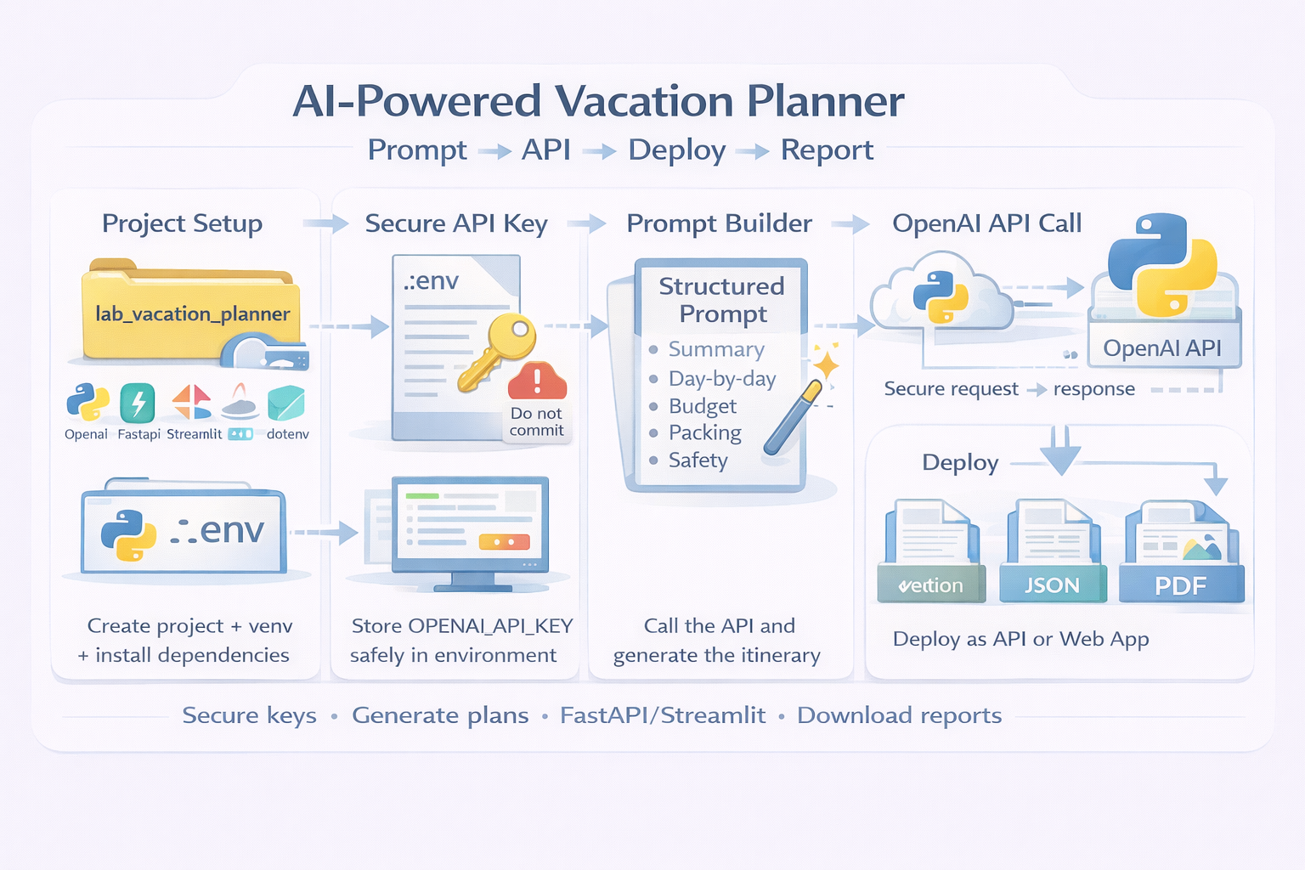

Setup

Step 1 — Create project folder

mkdir lab_vacation_planner
cd lab_vacation_planner

Step 2 — Create virtual environment

python -m venv .venv
Activate:
Mac/Linux
source .venv/bin/activate

Windows

.venv\Scripts\activate

Step 3 — Install required packages

python -m pip install openai fastapi uvicorn streamlit pydantic reportlab python-dotenv

Step 4 — Create .env file (IMPORTANT)
Create a file named:
.env
Add:
OPENAI_API_KEY=your_openai_api_key_here

⚠️ Never commit this file to GitHub.

Part 1 — Build AI Planner Engine
Create file:
planner.py

Step 1 — Imports + Setup

import os
import json
from dataclasses import dataclass, asdict
from datetime import date
from dotenv import load_dotenv
from openai import OpenAI

load_dotenv()

client = OpenAI(api_key=os.getenv("OPENAI_API_KEY"))

Step 2 — Define VacationRequest Model

@dataclass
class VacationRequest:
name: str
days: int
budget: int
style: str
destination_type: str
constraints: str

Step 3 — Build Structured Prompt

def build_prompt(req: VacationRequest) -> str:
return f"""
You are a professional travel planner.

Create a {req.days}-day vacation plan.

Traveler: {req.name}
Budget: {req.budget}
Travel style: {req.style}
Destination type: {req.destination_type}
Constraints: {req.constraints}

Output format:
1) Summary (3 bullets)
2) Day-by-day itinerary
3) Budget breakdown
4) Packing list
5) Safety tips
"""

Step 4 — Real OpenAI API Call
def call_openai(prompt: str) -> str:
try:
response = client.chat.completions.create(
model="gpt-4o-mini",
messages=[
{"role": "system", "content": "You are a structured travel planner."},
{"role": "user", "content": prompt}
],
temperature=0.7,
)
return response.choices[0].message.content

except Exception as e:
return f"[ERROR] OpenAI API call failed: {e}"

Step 5 — Generate Plan

def make_plan(req: VacationRequest) -> dict:
prompt = build_prompt(req)
plan_text = call_openai(prompt)

return {
"generated_on": str(date.today()),
"request": asdict(req),
"plan_text": plan_text,
}

Step 6 — Save Reports

def save_reports(plan: dict, base_name="vacation_report"):
with open(f"{base_name}.txt", "w", encoding="utf-8") as f:
f.write(plan["plan_text"])

with open(f"{base_name}.json", "w", encoding="utf-8") as f:
json.dump(plan, f, indent=2)

print("✅ Reports saved.")

Part 2 — FastAPI Deployment
Create file:
app_fastapi.py

Step 1 — FastAPI App

from fastapi import FastAPI
from pydantic import BaseModel
from planner import VacationRequest, make_plan, save_reports
from fastapi.responses import FileResponse

app = FastAPI(title="AI Vacation Planner")

class VacationRequestIn(BaseModel):
name: str
days: int
budget: int
style: str
destination_type: str
constraints: str = ""

@app.post("/plan")
def generate_plan(req: VacationRequestIn):
plan = make_plan(VacationRequest(**req.dict()))
save_reports(plan)

return {
"preview": plan["plan_text"][:300],
"download_txt": "/download/txt",
"download_json": "/download/json"
}

@app.get("/download/txt")
def download_txt():
return FileResponse("vacation_report.txt")

@app.get("/download/json")
def download_json():
return FileResponse("vacation_report.json")

Step 2 — Run API
uvicorn app_fastapi:app --reload
Open:
http://127.0.0.1:8000/docs

Part 3 — Streamlit Deployment (Alternative)
Create file:
app_streamlit.py

Step 1 — Streamlit App
import streamlit as st
from planner import VacationRequest, make_plan, save_reports

st.title("AI Vacation Planner 🌍")

name = st.text_input("Name", "Aina")
days = st.slider("Days", 1, 14, 3)
budget = st.number_input("Budget", 100, 10000, 1500)
style = st.selectbox("Style", ["relax", "adventure", "family", "food"])
destination = st.selectbox("Destination type", ["beach", "city", "nature"])
constraints = st.text_area("Constraints")

if st.button("Generate Plan"):
req = VacationRequest(
name=name,
days=days,
budget=budget,
style=style,
destination_type=destination,
constraints=constraints
)

plan = make_plan(req)
save_reports(plan)

st.subheader("Plan Preview")
st.text(plan["plan_text"])

st.download_button(
"Download TXT",
data=open("vacation_report.txt").read(),
file_name="vacation_report.txt"
)

st.download_button(
"Download JSON",
data=open("vacation_report.json").read(),
file_name="vacation_report.json"
)

Run:

streamlit run app_streamlit.py

Security Note
- Never hardcode API keys
- Always use environment variables
- Never expose API keys in frontend code
- Never commit .env to GitHub

Expected Output
Students should be able to:
- Input travel preferences
- Generate AI-powered itinerary
- See structured output
- Download reports
- Deploy working API or Web App

Optional Extensions

1) Add a cost estimation calculator
Idea: After you get an itinerary (or even before), estimate costs from simple rules: nights × hotel_rate + days × food_per_day + transport + activities.

from pydantic import BaseModel

class CostInputs(BaseModel):
nights: int
travelers: int = 1
hotel_per_night: float
food_per_day: float
local_transport_total: float = 0.0
activities_total: float = 0.0
flights_total: float = 0.0

def estimate_cost(c: CostInputs) -> dict:
lodging = c.nights * c.hotel_per_night
food = (c.nights + 1) * c.food_per_day * c.travelers
total = lodging + food + c.local_transport_total + c.activities_total + c.flights_total
return {
"breakdown": {
"lodging": round(lodging, 2),
"food": round(food, 2),
"local_transport": round(c.local_transport_total, 2),
"activities": round(c.activities_total, 2),
"flights": round(c.flights_total, 2),
},
"total": round(total, 2),
}
You can call estimate_cost(...) inside your /plan response and return estimated_cost.

2) Add multiple itinerary options (budget vs luxury)
Idea: Run the planner twice with different constraints and return both.
def build_prompt(user: dict, tier: str) -> str:
if tier == "budget":
style = "Budget-friendly choices, public transport, affordable eateries, free/low-cost activities."
else:
style = "Luxury choices, premium hotels, fine dining, private transport, curated experiences."

return f"""
You are a travel planner.
Create a {tier.upper()} itinerary.
Traveler preferences: {user}

Rules:
- {style}
- Provide a day-by-day plan
- Include estimated daily spend range
"""

async def generate_itinerary(openai_client, user: dict, tier: str) -> str:
prompt = build_prompt(user, tier)
# Call your OpenAI function here and return text (placeholder):
text = await call_llm(openai_client, prompt)
return text

# In your endpoint:
# budget_plan = await generate_itinerary(client, payload, "budget")
# luxury_plan = await generate_itinerary(client, payload, "luxury")
# return {"budget": budget_plan, "luxury": luxury_plan}

3) Add PDF export with ReportLab
Idea: Generate a PDF from the itinerary text and return it as a download.
from io import BytesIO
from fastapi.responses import StreamingResponse
from reportlab.lib.pagesizes import A4
from reportlab.pdfgen import canvas

def itinerary_to_pdf_bytes(title: str, content: str) -> bytes:
buf = BytesIO()
c = canvas.Canvas(buf, pagesize=A4)

width, height = A4
y = height - 50

c.setFont("Helvetica-Bold", 14)
c.drawString(50, y, title)
y -= 30

c.setFont("Helvetica", 10)
for line in content.splitlines():
if y < 60:
c.showPage()
c.setFont("Helvetica", 10)
y = height - 50
c.drawString(50, y, line[:110]) # simple wrap limit
y -= 14

c.save()
return buf.getvalue()

# Example FastAPI route:
# GET /plan/pdf?tier=budget
from fastapi import FastAPI, Query

app = FastAPI()

@app.get("/plan/pdf")
async def download_plan_pdf(tier: str = Query("budget")):
itinerary_text = "Day 1: ...\nDay 2: ..." # replace with real generated text
pdf_bytes = itinerary_to_pdf_bytes(f"Vacation Plan ({tier})", itinerary_text)

return StreamingResponse(
BytesIO(pdf_bytes),
media_type="application/pdf",
headers={"Content-Disposition": f'attachment; filename="vacation_plan_{tier}.pdf"'},
)

4) Add rate limiting to the API
Simple in-memory limiter (good for labs). Limit by client IP.
import time
from collections import defaultdict, deque
from fastapi import Request, HTTPException

RATE_LIMIT = 10 # requests
WINDOW_SECONDS = 60 # per 60 seconds
_hits = defaultdict(lambda: deque())

def check_rate_limit(ip: str) -> None:
now = time.time()
q = _hits[ip]

while q and (now - q[0]) > WINDOW_SECONDS:
q.popleft()

if len(q) >= RATE_LIMIT:
raise HTTPException(status_code=429, detail="Rate limit exceeded. Try again later.")
q.append(now)

@app.middleware("http")
async def rate_limit_middleware(request: Request, call_next):
ip = request.client.host if request.client else "unknown"
check_rate_limit(ip)
return await call_next(request)
(For production we’d use Redis-based limiting, but this is perfect for learning.)

5) Add authentication to FastAPI
Option A: Simple API Key (easy + common for internal APIs)
from fastapi import Header, HTTPException

API_KEY = "CHANGE_ME_TO_SOMETHING_SECRET"

def require_api_key(x_api_key: str | None):
if x_api_key != API_KEY:
raise HTTPException(status_code=401, detail="Invalid or missing API key.")

@app.post("/plan")
async def plan_trip(payload: dict, x_api_key: str | None = Header(default=None)):
require_api_key(x_api_key)
# continue with planning...
return {"ok": True}
Client sends header: X-API-Key: CHANGE_ME_TO_SOMETHING_SECRET
Option B: Basic Auth (also simple)
Use FastAPI’s security utilities if you want username/password, but API key is usually best for a lab.

Key Takeaways

1. Structured Prompts Produce Better AI Results
Well-designed prompts (clear sections, constraints, output format) lead to more consistent, usable, and professional AI-generated itineraries.

2. Secure API Key Management Is Critical
Using .env files and environment variables protects sensitive credentials and prevents accidental exposure in code repositories.

3. AI Integration Requires Both Logic and Infrastructure
Calling the OpenAI API is only one part — building models, validating inputs, handling errors, and structuring outputs are equally important.

4. Deployment Transforms Scripts into Real Applications
FastAPI enables backend APIs with Swagger documentation, while Streamlit allows rapid UI prototyping — turning AI logic into usable systems.

5. Automation Is End-to-End
A complete AI pipeline includes:
Prompt → API Call → Processing → Report Generation → Downloadable Output
This mirrors real-world AI product workflows.

